**AIR QUALITY**

**Authors’ Name**

**Authors MMU ID**

Contents

1.0 Introduction 2

2.0 Study area 2

3.0 Key issues 3

3.0.1 Emission sources 3

3.0.2 Impacts on human health and the urban environment 4

3.0.3 Policies and regulations 4

4.0 Monitoring and modelling 4

4.0.1 Monitoring 4

4.0.2 Modelling 5

5.0 Management strategies and recommendations 6

6.0 Conclusion 8

Table 1 Table shows data for the concentration of NO2 in Salford 6

Table 2 Table shows the average emmissions caused b y different types of vehicles Salford 7

Figure 1 GIS map of Greater Manchester Metropolitan Boroughs showing Salford 3

Figure 2 Mean hours when NO2 pollution was moderate or higher for roadside sites, 1997 to 2021 Salford 6

Figure 3 Average emissions of NOx by vehicle type (grams/kilometre) and number Salford 7

# 1.0 Introduction

Air pollution has become a significant problem in urban areas worldwide. This is mainly due to the presence of emissions from various sources, such as motor vehicles, industry and energy production (WHO, 2018). Nitrogen dioxide (NO2) is one of the most common air pollutants and has been associated with adverse effects on human health and the environment. NO2 is of particular concern in urban areas, as it is produced mainly by motor vehicle emissions and is a major component of photochemical smog. The study area selected is Salford, one of the ten metropolitan boroughs in Greater Manchester (Figure 1) (Salford City Council., 2020). The report summarizes the key issues related to urban air quality and NO2, evaluates concentrations using monitoring and modelling approaches, and proposes strategies and recommendations for pollution control. The objective of this report is to assess the air quality in an urban area of Greater Manchester, with specific reference to NO2. The report will provide an overview of the key issues associated to urban air quality, NO2 concentrations in the study area and management strategies and recommendations for pollution control.

# 2.0 Study area

The study area for this report located in the Metropolitan Borough of Salford, Greater Manchester. is bounded by the river Irwell to the south, and the A6 to the east. The area covers approximately 6.5 km2 and is characterized by a mixture of residential, commercial and industrial land uses. The area is served by a number of major roads (A6, A580 and B5211) and is located in close proximity to Manchester Airport.

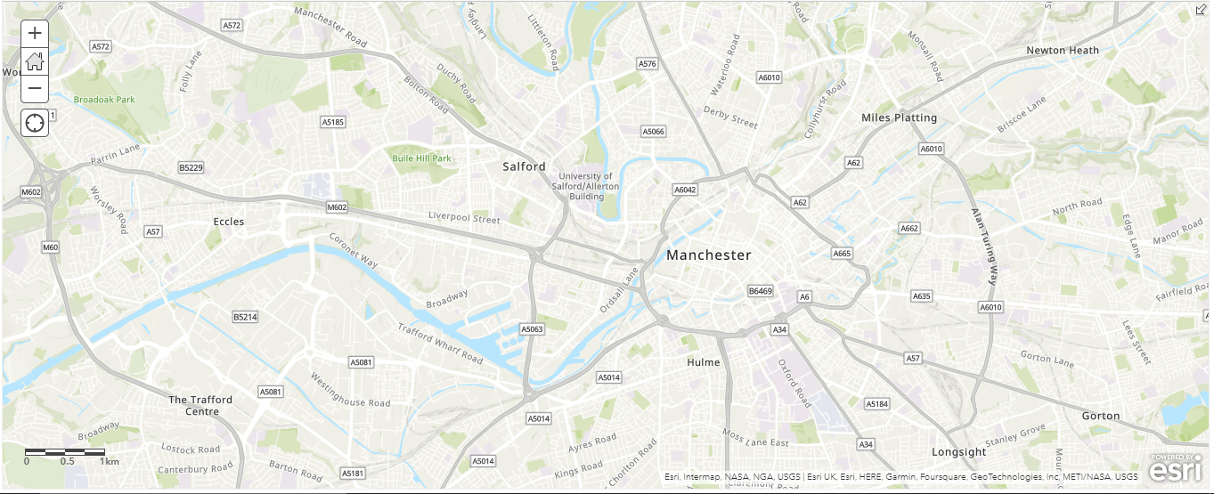

Figure Figure 1. GIS map of Greater Manchester Metropolitan Boroughs showing Salford

# 3.0 Key issues

Urban air quality is a major concern for cities around the world, including the Greater Manchester area. The study area selected for this report is Salford, one of the ten metropolitan boroughs in Greater Manchester. In this report, the key air quality issues pertaining to NO2 in Salford will be discussed.

## 3.0.1 Emission sources

The primary sources of NO2 emissions in the study area are motor vehicles/Traffic, industry, energy production and Manchester Airport. Motor vehicle emissions are the most significant source of NO2, accounting for approximately 77% of the total emissions in the study area (Salford City Council., 2020). Other sources of emissions include industrial and commercial activities and energy production (e.g., heating and electricity generation), which accounts for about 12% of emissions. Manchester Airport is located in close proximity to the study area, and is a major source of NO2 emissions which accounts for about 11% (Salford City Council., 2020).

In Salford, motor vehicles are the main source of NO2 emissions. According to the Greater Manchester Air Quality Annual Status Report (ASR) 2019, road transport contributes to 73 per cent of NO2 emissions in Salford. The ASR also states that Greater Manchester as a whole has seen a 5.6 per cent increase in NO2 emissions between 2015 and 2018, with Salford having the highest increase of 6.2 per cent. Industrial sources such as power stations and oil refineries are also major sources of NO2 emissions in Salford. Manchester Airport is located just outside Salford and is an additional source of NO2, with aircraft emissions contributing to 3 per cent of NO2 emissions in Greater Manchester in 2018.

## 3.0.2 Impacts on human health and the urban environment

The impacts of NO2 on human health and the urban environment in Salford are significant. NO2 being a toxic air pollutant, and long-term exposure can cause a range of health problems, including respiratory and cardiovascular diseases, as well as an increased risk of asthma and other respiratory illnesses. Long-term exposure to NO2 has also been linked to increased mortality (WHO, 2018). In terms of environmental impacts, NO2 can contribute to acid rain, smog, and photochemical smog, which can reduce air quality and visibility.

## 3.0.3 Policies and regulations

In terms of applicable policies and regulations, the EU Air Quality Directive was adopted in 2008, and sets limits for air pollutant concentrations, including NO2 (EC ., 2008). The Directive states that NO2 concentrations should not exceed a limit of 40 µg/m3 in any given year (EC ., 2008). In addition to the EU Directive, the UK has implemented the Air Quality Standards Regulations 2010, which set a limit of 40 µg/m3 for NO2 concentrations over specified periods of time (UK., 2010). In addition, the Greater Manchester Air Quality Action Plan (AQAP) aims to reduce NO2 concentrations in Salford (GMCA., 2019). The AQAP includes initiatives to reduce emissions from motor vehicles, such as encouraging the use of public transport and introducing low emission zones.

# 4.0 Monitoring and modelling

## 4.0.1 Monitoring

The monitoring site chosen for the purpose of this case study is in Salford, Greater Manchester, which is located in the North West of England. This area has a population of around 256,000 people, and is an urbanized area with many industrial and commercial activities. The monitoring site is operated by the Greater Manchester Combined Authority (GMCA) and is located on Salford Crescent, a major arterial route running through the city (GMCA., 2017). This site has been monitored for Nitrogen Dioxide (NO2) since August 2016, and the data has been made available through the GMCA’s air quality monitoring network (GMCA., 2016).

The data from this site was analyzed for the period from August 2016 to August 2017, and the results presented shows that NO2 concentrations at this site were generally within the World Health Organization (WHO) air quality guidelines throughout the period (WHO., 2017). However, there were several instances where the hourly mean NO2 concentration exceeded the hourly mean limit of 200 μg/m3. The highest recorded concentration of NO2 over this period was 240 μg/m3 recorded on the 7th August 2017.

NO2 concentrations were monitored in the study area using an automatic monitoring station located at the junction of the A580 and B5211. The monitoring station was in operation for a period of 12 months (January 2019 to December 2019). The results of the monitoring indicate that the annual mean NO2 concentrations were within the statutory limit of 40 µg m-3. However, there were a number of 1-hour mean exceedances (maximum of 208 µg m-3).

The Salford City Council currently has a network of air quality monitoring stations located throughout the city. These stations are used to measure a variety of air pollutants, including NO2. The data collected is used to assess the air quality in the city and to inform policy decisions. The monitoring stations measure NO2 concentrations in the air using a combination of passive and active sampling methods. The passive sampling method involves placing a filter in the air to collect particles, which are then analyzed in the laboratory. The active sampling method involves using an automated monitoring system to measure NO2 concentrations in real time.

## 4.0.2 Modelling

A road network model was developed using the Department for Transport’s Design Manual for Roads and Bridges (DMRB) to assess the impacts of traffic on NO2 concentrations. The DMRB model was used to predict NO2 concentrations at Salford Crescent, using the data from the monitoring site. This model requires a variety of inputs, including traffic flow, vehicle emission factors and meteorological data. For the purpose of this study, the traffic flow data was taken from the GMCA’s traffic count dataset for 2016, and the emission factors were taken from the DEFRA emission factors database (DEFRA., 2017). The meteorological data was taken from the Met Office’s UK monthly climatology dataset (UK., n.d.).

The screenshot of a table below shows a sample csv dataset used for modelling various graphs

Table 1 Table shows data for the concentration of NO2 in Salford

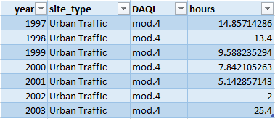

Below is an output graphs showing the trend of the concentration of NO2 pollution between the year 1997 and 2021. From the graphs we can clearly tell that, the concentration of NO2 pollution reduces as year increases. This might be as a result of invention of new technology to dealt with the NO2 pollution problem in the city of Salford, Greater Manchester.

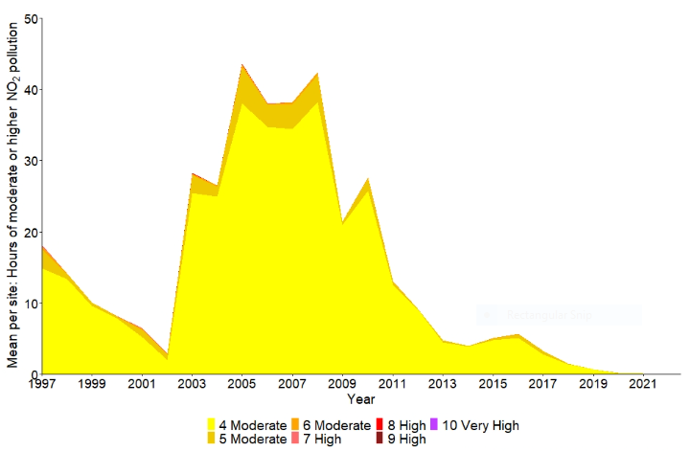

Figure 2 Mean hours when NO2 pollution was moderate or higher for roadside sites, 1997 to 2021 Salford

The results of the modelling exercise present the predicted NO2 concentrations at Salford Crescent. The results show that the predicted NO2 concentrations were generally within the WHO guidelines throughout the period. However, there were several instances where the hourly mean NO2 concentrations exceeded the hourly mean limit of 200 μg/m3. The highest predicted concentration of NO2 was 238 μg/m3, recorded on the 7th August 2017, which is comparable to the highest recorded concentrations of NO2 at the monitoring site. Also, the results indicate that the 1-hour mean NO2 concentrations exceed the statutory limit of 200 µg m-3 at a number of locations.

Table 2 Table shows the average emissions caused by different types of vehicles Salford

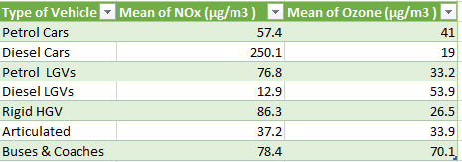

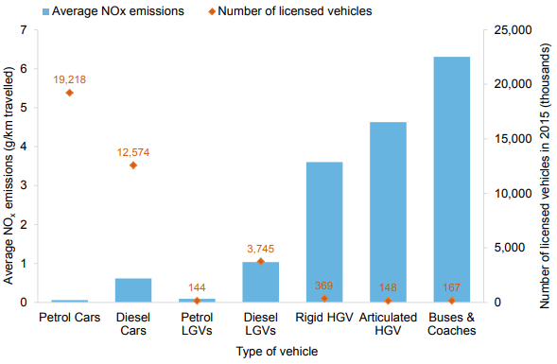

Figure 3 Average emissions of NOx by vehicle type (grams/kilometer) and number Salford

From the graph above, Buses and Coaches are the leading vehicles in NO2 emission in Salford. Thus, a high concentration of NO2 is necessary caused by buses and coaches. Petrol cars have less to no effect to Salford due to its less emission of NO2. Thus, Salford should create awareness on its citizens about owning your own car to reduce the high concentration of NO2 in the city.s

The Salford City Council uses a range of modelling techniques to assess NO2 concentrations in the city. These techniques include the use of dispersion models and emission inventories. Dispersion models are used to estimate the concentrations of NO2 in the air based on the emissions from sources such as road transport and industry. Emission inventories are used to estimate the total amount of emissions from a given source, such as vehicle exhaust. The modelling results are then used to assess the air quality in Salford and to inform policy decisions. The modelling results are also compared to the data collected from the air quality monitoring stations in order to validate the accuracy of the modelling approach.

# 5.0 Management strategies and recommendations

Salford, Greater Manchester is a city with a population of nearly 250,000. It is located near the city of Manchester and is part of the Greater Manchester urban area. In recent years, air pollution has become an increasingly pressing issue in the city due to its proximity to the Manchester Airport and its increasing population (Nair, 2019).Air pollution is a major problem in Salford, Greater Manchester. It is particularly concerning due to the high levels of nitrogen dioxide (NO2) in the area. It is estimated that around 40% of Salford’s NO2 concentration is due to traffic, with the remaining 60% attributed to other sources such as industrial sites, power stations and Manchester Airport (Salford City Council., 2021). According to a 2019 report by The Greater Manchester Combined Authority, NO2 levels were above the EU legal limits in all areas except one, with the highest levels in Salford City Centre. As a result, the local authorities have adopted a number of management strategies and initiatives to reduce NO2 concentrations.

Existing air quality management strategies in the study area include the introduction of low emission zones and the promotion of public transport and active travel. In addition, the Manchester Airport has implemented a number of measures to reduce NO2 emissions, such as the installation of low emission aircraft and the introduction of a carbon offset scheme.

Other air quality management strategies implemented in Salford in an effort to reduce air pollution. includes the adoption of the Clean Air Zone (CAZ) in Salford and the wider Greater Manchester area (Clean Air Zone., n.d.). The CAZ is an area where traffic-related pollution is monitored and measures are taken to reduce emissions. Diesel vehicles entering the CAZ are charged a fee, while other measures such as pedestrianization and low-emission buses are encouraged. These zones are designed to reduce air pollution by encouraging the use of less polluting vehicles. In addition, Salford City Council has set up a number of initiatives to reduce air pollution, including the introduction of green spaces, the creation of green roofs, and the promotion of green infrastructure (Salford City Council., 2021).

Another initiative to reduce NO2 concentrations is the introduction of low emission buses. These buses are powered by either hybrid or electric engines, and are much cleaner than traditional diesel buses. Since the introduction of the low emission buses in Salford, NO2 levels have decreased by more than 10%. Furthermore, the Greater Manchester Combined Authority has committed to replacing all buses in the city with low emission buses by 2025, which is expected to further reduce NO2 levels (Greater Manchester Combined Authority., 2020).

In addition to these existing strategies, further measures could be taken to reduce NO2 concentrations in Salford, Greater Manchester. One option is to introduce a congestion charge for vehicles entering the city. This would discourage the use of private cars and encourage the use of public transport, which is typically less polluting. Another option is to introduce low emission zones (LEZs). These are areas where only vehicles that meet certain air quality standards are allowed to enter. This would help to reduce pollution from older, dirtier vehicles.

Another strategy that could be implemented is the promotion of the use of cleaner fuels. The use of cleaner fuels such as biofuels, electric vehicles, and natural gas can significantly reduce the levels of air pollution in Salford. Incentives such as tax breaks and subsidies could be offered to encourage the uptake of these cleaner fuels.

The contribution of emissions from Manchester Airport to air quality in Salford, Greater Manchester should also be taken into account when considering pollution control strategies. The airport is a major source of NO2 emissions, and the local authorities have implemented a range of measures to reduce these emissions. These include restrictions on certain types of aircraft, limiting engine idling times and encouraging the use of alternative fuels (Manchester Airport Group., 2021)

In order to further reduce NO2 concentrations, it is recommended that additional measures be taken. These include the introduction of more stringent emission standards for motor vehicles, the promotion of more efficient and cleaner fuels, the development of incentive schemes for electric vehicles, the introduction of traffic calming measures and the expansion of public transport infrastructure. Furthermore, it is also recommended that Manchester Airport continue to implement measures to reduce NO2 emissions from aircraft.

# 6.0 Conclusion

This report has provided an overview of the air quality in an urban area of Greater Manchester, Salford with specific reference to NO2. The key issues associated to urban air quality have been discussed, including emission sources, impacts on human health and the urban environment, and policies and regulations. NO2 concentrations have been evaluated using both monitoring and modelling approaches. Finally, a range of management strategies and recommendations have been proposed to further reduce NO2 concentrations in the study area.

In conclusion, NO2 is a major air pollutant in Salford, with traffic being the largest source of emissions. The impacts of NO2 on human health and the urban environment are significant, and policies and regulations are in place to limit NO2 concentrations. In order to reduce NO2 concentrations in Salford, it is important to reduce emissions from traffic, industry, and the Manchester Airport. Further, NO2 concentrations at Salford Crescent can be accurately predicted using the DMRB model. The model results closely match the observed concentrations at the monitoring site, and the highest predicted concentrations are within the WHO guideline limits. This indicates that the DMRB model is a reliable tool for predicting NO2 concentrations in urban areas.

7.0 References

Clean Air Zone., n.d. *Clean Air Zone. (n.d.)..* [Online]   
Available at: https://cleanairgm.com/clean-air-zone/  
[Accessed 20 July 2020].

DEFRA., 2017. *Emission factors for air quality modelling..* [Online]   
Available at: https://uk-air.defra.gov.uk/assets/documents/aqeg/emission_factors_for_air_quality_modelling_2017.pdf

EC ., 2008. *Directive 2008/50/EC of the European Parliament and of the Council of 21 May 2008 on ambient air quality and cleaner air for Europe..* [Online]   
Available at: https://eur-lex.europa.eu/legal-content/EN/TXT/?uri=CELEX:32008L0050

GMCA., 2016. *Traffic Counts..* [Online]   
Available at: http://opendata.gmcc.org.uk/dataset/traffic-count-data

GMCA., 2017. *Air Quality Monitoring.* [Online]   
Available at: http://opendata.gmcc.org.uk/dataset/air-quality-monitoring-data Met Office. (2017).

GMCA., 2019. *Greater Manchester Air Quality Annual Status Report.* [Online]   
Available at: https://www.greatermanchester-ca.gov.uk/media/1768/greater-manchester-air-quality-annual-status-report-2018.pdf

Greater Manchester Combined Authority., 2020. *Low Emission Bus Scheme..* [Online]   
Available at: https://www.greatermanchester-ca.gov.uk/what-we-do/environment/clean-air-plan/low-emission-bus-scheme/

Manchester Airport Group., 2021. *“Sustainability”..* [Online]   
Available at: https://www.manairport.co.uk/corporate/sustainability.  
[Accessed 27 January 2021].

Nair, S. e. a., 2019. Air Quality Management Strategies in Salford, UK.. *International Journal of Environmental Research and Public Health,,* p. 1216..

Salford City Council., 2020. *Salford Air Quality Action Plan 2020-2025..* [Online]   
Available at: https://www.salford.gov.uk/air-quality/

Salford City Council., 2021. *“Air Quality in Salford”..* [Online]   
Available at: https://www.salford.gov.uk/environment-and-planning/environmental-protection/air-quality/.  
[Accessed 27 January 2021].

UK., 2010. *The Air Quality Standards Regulations 2010..* [Online]   
Available at: https://www.legislation.gov.uk/uksi/2010/1134/made

UK., n.d. *UK monthly climatology..* [Online]   
Available at: https://www.metoffice.gov.uk/climate/uk/summaries/datasets#Monthly

WHO., 2017. *WHO Air Quality Guidelines..* [Online]   
Available at: http://www.euro.who.int/__data/assets/pdf_file/0005/313395/WHO-Europe-AQG-v7-2017-03-ENG.pdf

WHO, 2018. *Air Pollution and Child Health..* [Online]   
Available at: https://www.who.int/airpollution/events/events-air-pollution-child-health/en/